JOE TRAN & ASSOCIATES

www.RWJoeTran.com

Fixed-Rate and Adjustable-Rate Mortgages

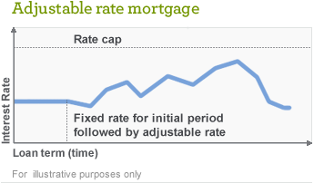.

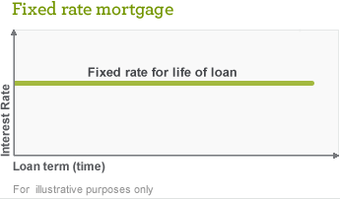

Features
Features

Your interes t rate and m onthly principal and interest (P&I)
paym ents rem ain the s am e for the life of your loan. Available in a variety of loan term options .
You m ay be able to add extra features s uch as interest- only payments or temporary buydowns.1
Your interes t rate and m onthly principal and interest (P&I)
paym ents rem ain the s am e for an initial period of 3, 5, 7, or
10 years , then adjus t annually.
Loans available in a variety of longer term s .
Includes interest rate caps that s et a lim it on how high your interes t rate can go.
You m ay be able to add extra features s uch as interest- only payments or temporary buydowns.

Benefits
Benefits

Predictable m onthly P&I paym ents allow you to budget m ore eas ily.
Protection from ris ing interes t rates for the life of the loan, no m atter how high interes t rates go.
May be a good choice if you plan to s tay in your hom e for a long tim e.
Typically ARMs have a lower initial interes t rate than on a fixed-rate m ortgage.
The interest rate cap lim its the m axim um am ount your P&I paym ent m ay increas e at each interes t rate adjus tm ent and over the life of the loan.
May provide flexibility if you expect future incom e growth or if you plan to m ove or refinance within a few years .

Considerations
Considerations

The overall interes t you pay is higher on a longer-term loan than on a s horter-term loan.
On a s horter-term loan, the m onthly P&I paym ent is typically higher than on a longer-term loan.
If you choos e an interes t-only option, you cannot build equity through m onthly interes t-only paym ents without m aking voluntary principal paym ents during the interes t only period.
Monthly principal and interes t paym ents m ay increas e when the interes t rate adjus ts .
Your m onthly principal and interes t paym ents m ay change every year after the initial fixed period is over.
If you choos e an interes t-only option, you cannot build equity through m onthly interes t-only paym ents without m aking voluntary principal paym ents during the interes t only period.

