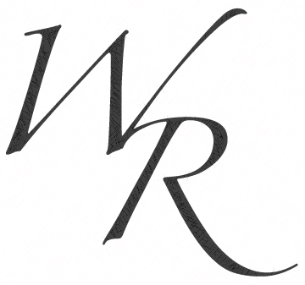

**8 Questions to Ask your Realtor**

**In an ever-changing market, experience, skills, and market knowledge are crucial. Choosing the “Right Agent” to sell your home is not a decision you should take lightly. At WR Properties, we pride ourselves on being market leaders and delivering you “Winning Results” through our years of experience and vast market knowledge. When interviewing agents, here are a few key questions to ask:**

**1. How long have you been in business?**

**2. Is Real Estate your part-time or full-time job?**

**3. How many sales did you have in 2012?**

**4. How many sales do you have year-to-date?**

**5. What is the average sales price of your closings?**

**6. What is the average sales price for this area?**

**7. What is your commission structure?**

**8. What is your list price to sales price ratio?**

**Tel:** 925.634.3100

**Fax:** 925.634.3190

**Address:** 651 First Street, Brentwood, CA 94513

**Web:** www.WRPropertiesBayArea.com

**Tel:** 925.634.3100

**Fax:** 925.634.3190

**Address:** 651 First Street, Brentwood, CA 94513

**Web:** www.WRPropertiesBayArea.com

**WR Properties & Property Management**

**Tel:** 925.634.3100

**Fax:** 925.634.3190

**Address:** 651 First Street, Brentwood, CA 94513

**Web:** www.WRPropertiesBayArea.com

**Tel:** 925.634.3100

**Fax:** 925.634.3190

**Address:** 651 First Street, Brentwood, CA 94513

**Web:** www.WRPropertiesBayArea.com