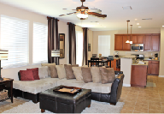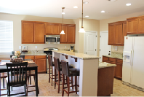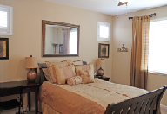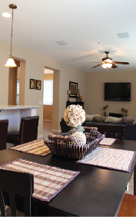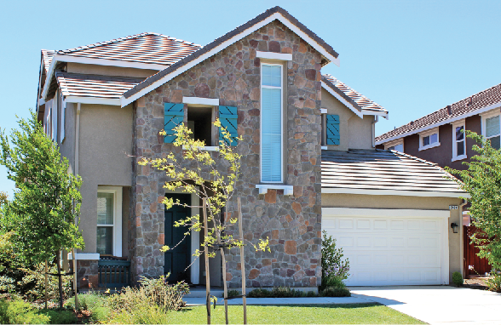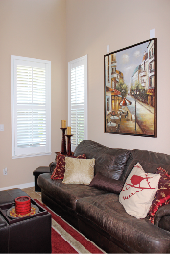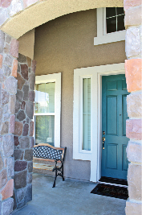

*Features deemed accurate, but not guaranteed.

**Name**

Realtor®

Cal-BRE# 00000000

Direct: (000) 000-0000

Email

Web Address

*Offered at:*

*$000,000*

BEDROOMS: 0

BATHROOMS: 0

LIVING: 0,000 sq.ft.

LOT SIZE: 0,000 sq.ft.

GARAGE: 0-Car

Key Details

Address or Website URL for the Property

Flyer Title

Place property description here. Place property description here. Place property description here. Place property description here. Place property description here.

* List property features here.
* List property features here.
* List property features here.
* List property features here.
* List property features here.
* List property features here.
* List property features here.
* List property features here.
* List property features here.
* List property features here.
* List property features here.